4.4 The Mean Value Theorem

The Mean Value Theorem is one of the most important tools in mathematical analysis. We begin this section by stating a theorem that will be crucial in the proof of the Mean Value Theorem.

Theorem (Rolle’s Theorem): Let f be a function that satisfies the following three hypotheses:
- f is continuous on the closed interval .
- f is differentiable on the open interval .
Then there is a number c in such that .

General Idea:

Proof:
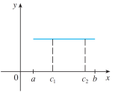
We break the proof into three cases.

Case 1: , a constant.

Case 2: for some x in .

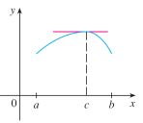
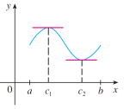

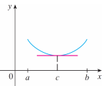

Case 3: for some x in .

Question: What does Rolle’s Theorem tell us about a ball that is thrown upward from ground level and comes back to the ground?

Example 1: Consider the function on .
- Verify that the hypothesis of Rolle’s theorem are satisfied on the given interval.

- Find all values of c in that interval that satisfy the conclusion of the theorem:

Example 2 (if time permits): Use Rolle’s Theorem to prove that the equation has exactly on real solution.

Theorem (The Mean Value Theorem): Let f be a function that satisfies the following hypotheses:
- f is continuous on the closed interval .
- f is differentiable on the open interval .
Then there is a number c in such that .

General Idea:

Proof:
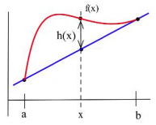
We begin by constructing an equation for the secant line AB.

Example 3: Verify that the function satisfies the conditions of the Mean Value Theorem on the interval . Then find all numbers c that satisfy the conclusion of the Mean Value Theorem.

Question: If for all x in , what can we say about the function f ?

Theorem: If for all x in , then f is constant on .

Corollary: If for all x in, then there is a constant C such that for every x in .

Example 4: Use the most recent theorem to prove the most recent corollary.
(Hint: Consider the function )

